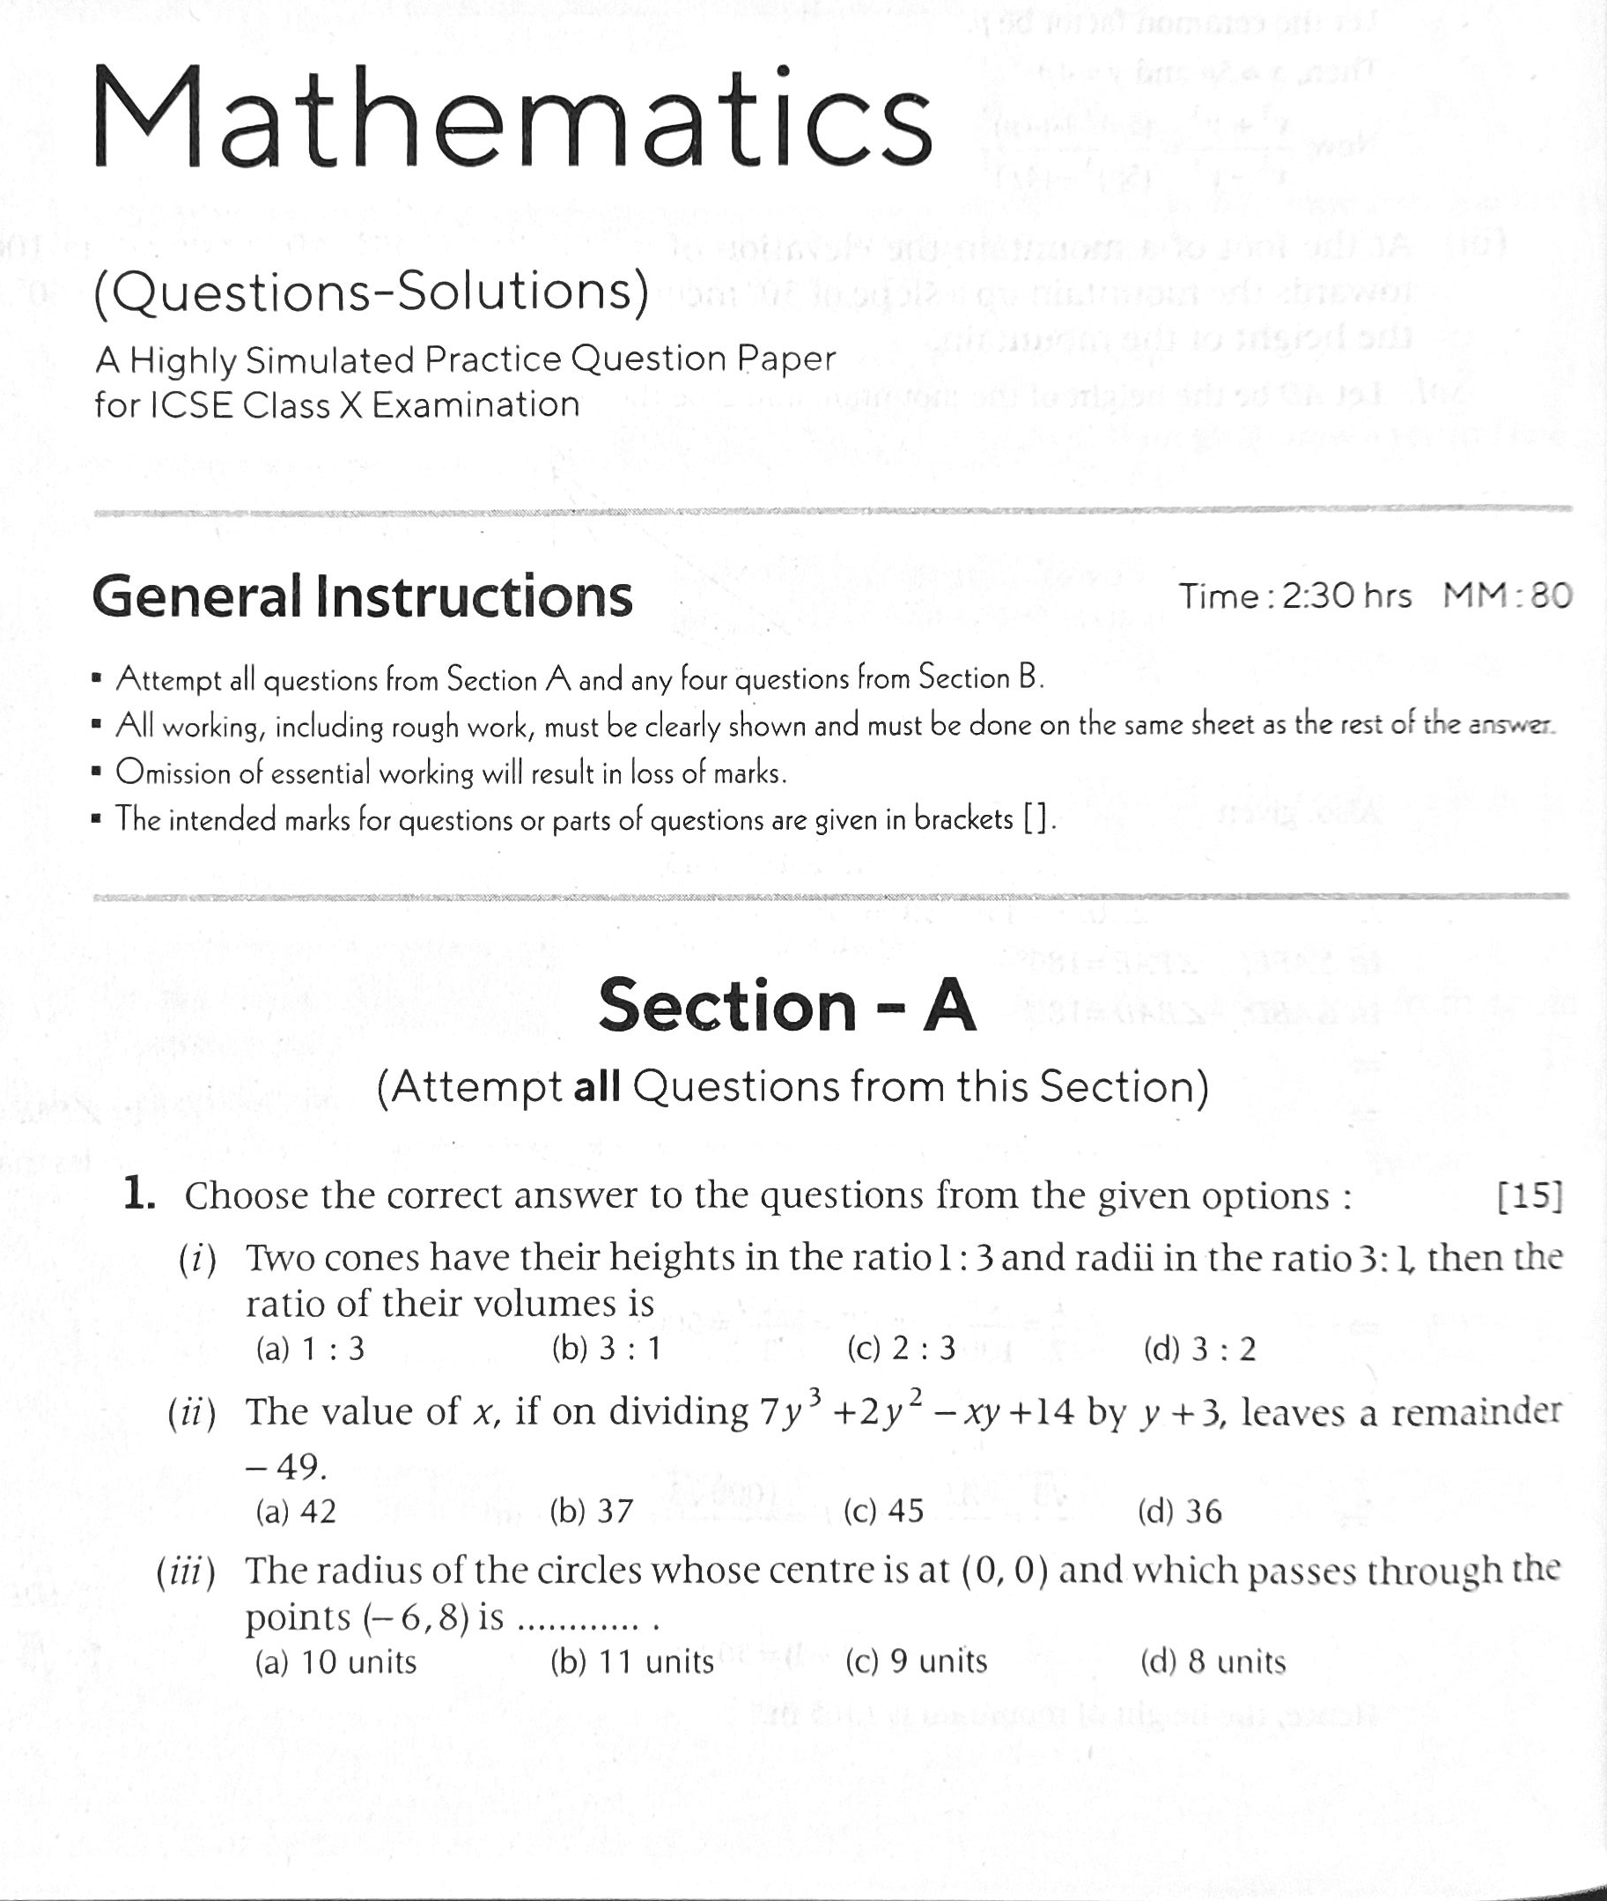

(By Subrata Sir & group of ICSE and CBSE school teachers)

GUIDELINES



Mock Test -

